Instruction/Notes: | This exam is open books and open notes.

Consider a case of an online examination system, which can be used by an instructor to design and administer an exam to students. An exam can comprise of questions that may be of several types (e.g. multiple choice, fill in blanks, etc.) as illustrated in the figure below:
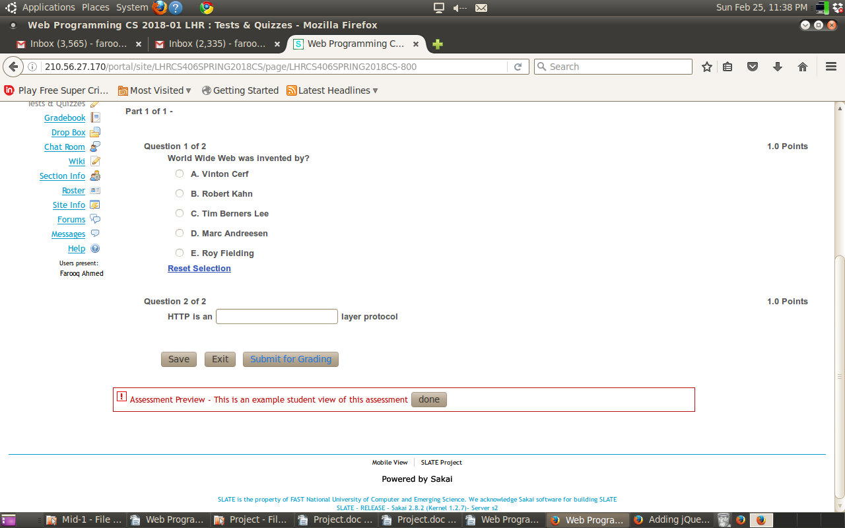
Consider the following class diagram for the Question hierarchy:
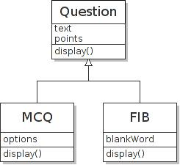
A basic Question has two attributes: text that contains the statement and points that may be earned on correct answer. MCQ (multiple choice) is a special question type that has an options attribute for a list (array) of choices. Likewise, FIB (fill in blank) is a special question type that has a blankWord attribute representing that word in the question text which is to be left as a blank (for students to answer). All Question types has a display function to generate the correct HTML.

Question 1 (Javascript) (5+5+5 pts)
(a) Write object-oriented Javascript code using the constructor functions to show how to realize the Question inheritance hierarchy. You cannot use the class based syntax.
(b) Give detailed implementation of MCQ display function to generate correct HTML for MCQ.
(c) Give detailed implementation of FIB display function to generate correct HTML for FIB.

Question 2 (CSS) (5+5 pts)
(a) Write a CSS rule to style all radio buttons (input type radio) that are used to represent options of a MCQ only (and not any other radio button used elsewhere), such that options are stacked vertically. Use your own HTML (in answer to Q1.b) as a basis to determine structure.
(b) Describe the resultant style effect of the following CSS rules on the given HTML below:
p , .text { font-weight : normal ; padding-left : 0px ; color : black}
.text { background-color : grey }
p.text { font-weight : bold ; padding-left : 10px }
<p class='text'> World Wide Web was invented by?</p>

